import matplotlib.pyplot as plt

apps = ['Instagram', 'YouTube', 'WhatsApp', 'Zomato', 'Spotify']
time_spent = [2, 3, 1.5, 0.5, 1]

plt.pie(
time_spent,
labels=apps,
autopct='%1.1f%%'
)

plt.title("Daily App Usage")
plt.show()
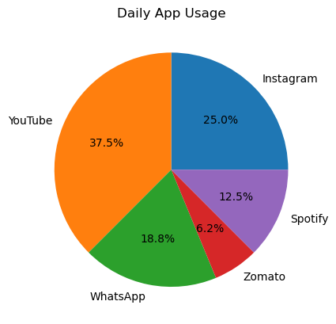
import matplotlib.pyplot as plt

categories = [
'Food Delivery',
'Shopping',
'Entertainment',
'UPI Payments'
]

spending = [3000, 5000, 2000, 1500]

explode = [0, 0.1, 0, 0]

plt.pie(
spending,
labels=categories,
autopct='%1.1f%%',
explode=explode
)

plt.title("Monthly Online Spending")
plt.show()
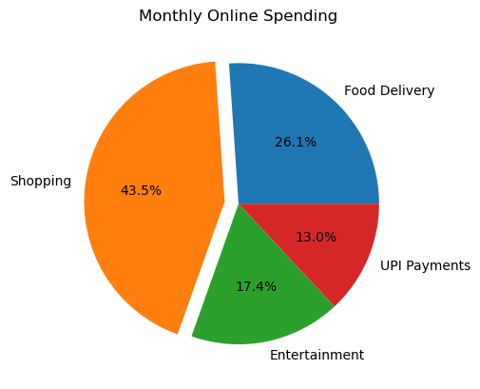
import matplotlib.pyplot as plt

categories = [
'Food Delivery',
'Shopping',
'Entertainment',
'UPI Payments'
]

spending = [3000, 5000, 2000, 1500]

fig, ax = plt.subplots()

ax.pie(
spending,
labels=categories,
autopct='%1.1f%%'
)

circle = plt.Circle(
(0, 0),
0.70,
fc='white'
)

ax.add_artist(circle)

plt.title("Monthly Online Spending")
plt.show()
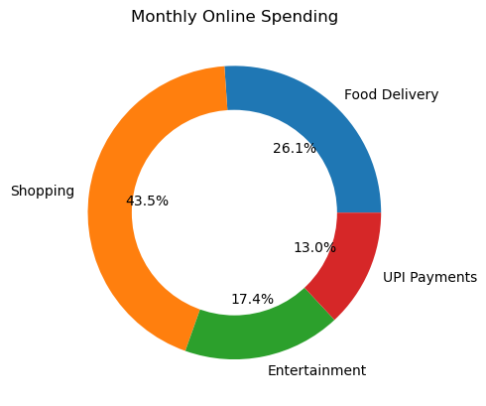
import matplotlib.pyplot as plt

teams = [
'CSK',
'Mumbai Indians',
'RCB',
'KKR'
]

followers = [
16000000,
14000000,
13000000,
7000000
]

fig, ax = plt.subplots()

ax.pie(
followers,
labels=teams,
autopct='%1.1f%%'
)

circle = plt.Circle(
(0, 0),
0.70,
fc='white'
)

ax.add_artist(circle)

ax.set_title("IPL Teams Instagram Followers Share")

plt.show()
